REPORT FOR GROCERY BILLING SYSTEM

PYTHON PROGRAMING (INT 213)

LOVELY PROFESSIONAL UNIVERSITY



**Submitted by : Roshan Prusty**

**Registration number : 12017337**

**Roll number : RK20SJB73**

**Section : K20SJ**

**Professor : Usha Mitta**

**Acknowledgement**

I express my sincere gratitude and thanks Ms. Usha Mittal (python faculty) for providing me the excellent opportunity to do a project on grocery billing system and providing me with all the essential element required for the completion and enhancement of this project.

I would like to thank you those respondents who have taken pain in successful completion of my project

**Introduction**

The project “billing system” is an application to automatic the process of ordering and billing of a “departmental store”. This web based application is designed considering the chain of departmental store which is located in various cities. This application also administrates its users and customers

**Abstract**

Grocery Billing System The **Grocery Billing System** with Source Code is a Python program where you can calculate and generate a billing receipt. The purpose of the system is to automate the calculation and efficiently generate the purchase bill digitally. The project was built with the use of tkinter module where it is compose of different widget that basically use for designing the interface. The project can be openly-access without the use of any kind of login information. The user can do the inputting of quantity of the ordered items, he/she also need to enter the name of the customer and phone number. After the order is done the user will click the Total button in order to display the total ordered item and click the Generate Bill to display the receipt of the purchased item. This project is useful to those have a grocery business it could help a lot when it comes for automating the calculation of transaction. The **Grocery Billing System** is a simple project that contains the basic functionality of python in order for you to learn the flow of the system..

**Objective**

The project will serve the following objective :-

* Add and maintain records of available products.
* Add and maintain customer details.
* Provides the bill to the customer the products they buyed
* Provides a convenient solution of billing system.
* Make a easy to use environment for users and customers.

**PROJECT CATEGORY**

CORE PYTHON:

This project is based on the concepts of core PYTHON.

**FUTURE SCOPE**

1.This project will help the store keeper in fast billing.

2.This project enable store keeper to maintain agreat database of all customers visited and purchase product from store.

3.Project will enable to see the report regarding product and category.

4.It is easy to maintain in future prospect.

**ANALYSIS OF PRESENT SYSTEM**

Before we begin a new system it is important to study the system that will be improved or replaced (if there is one). We need to analyse how this system uses hardware, software, network and the people resources to convert data resources, such as transaction data, into information products, such as report analysis and displays. Thus we should document how the information system activities of input, processing output, storage and control are accomplished

**CHARACTERSTIC OF THE PROPOSED SYSTEM**

1. Easiness in modification of data.
2. User friendly: They proposed is user friendly.
3. Reports are easily generated: Reports can be easily generated in a proposed system. So any type of reports can be generated in a proposed system, which helps the managers in a decision-making activity.
4. No or very few paperwork: The proposed system either does not require paper work or very few paper is required. All the data is feted into the computer immediately and various bills and reports can be generated through computers
5. Supports strategic competitive advantage: proposed system supports strategic competitive advantages. Since the proposed system provide easiness in reports generating it will provide strategic advantage among competitors.
6. Computer operator control: computer operator will be there no errors. Moreover storing and retrieving of information is easy. So work can be done speedily and in time

**DATA FLOW DIAGRAM**

A data flow diagram is graphical representation that depicts the information flow and the transforms that are applied as date moves from input to output. It can be used to represent a software at any level of abstraction. In fact DFDs may be partitioned in to levels. That represents increasing information flow and functional details. DFDs are defined in levels with every level decreasing the level of abstraction as well as defining a greater detail of the functional organs of the system. A zero level DFD also known as context or fundamental system model represents the entire software elements as a single bubble with input and output data entities which are indicated as incoming and outgoing arrows. Data Flow Diagram help understanding the basic flow of data from one process to another process.

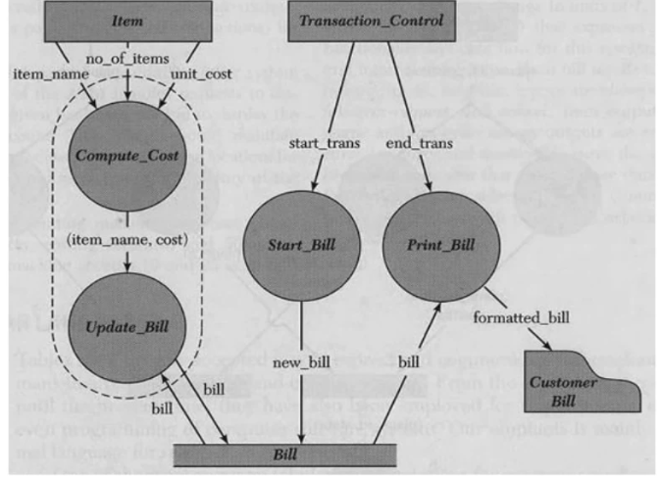

**PROPOSED MODULE**

* **Customer details :** Details about the customer is added such as the customer name, phone number etc.

Here we will take all the details from the customer

* **Product Details:** Details about the products such as product name is given

In the product column there is total three category

* 1. Cosmetic
  2. Grocery
  3. Cold drinks

In every category there is sub category there we have to select and add the quantity

* **Bill Generation:**As the customer buys the products and comes to the billing counter, the user can enter the item name and quantity of the item the customer has purchased. The system will display all the items depending on the category whose name starts with the letter selected. He can select out of those displayed. Finally a separate bill will be generated for each customer. The total will be automatically calculated
* **Stock Report:**The products bought from the vendor will be entered here and after adding the quantity this will be added to the stock list.
* **Bill menu:** In the bill menu it will show the total cosmetic product price, total grocery price and total cold drink price automatic it will show after clicking on the total

**OUTPUT SNAPSHOTS**

* **customer details**

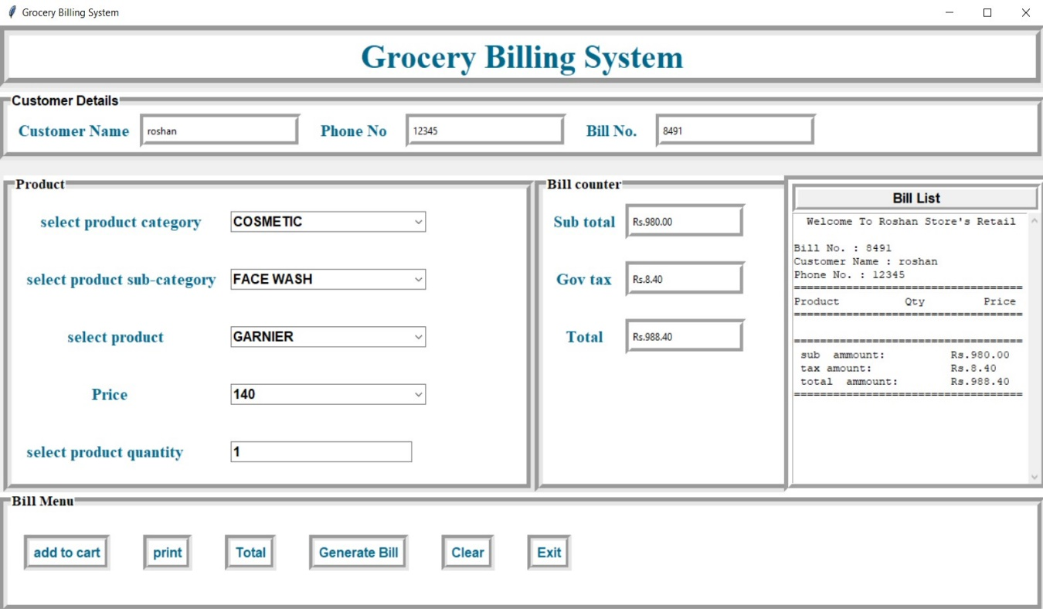

* **products**

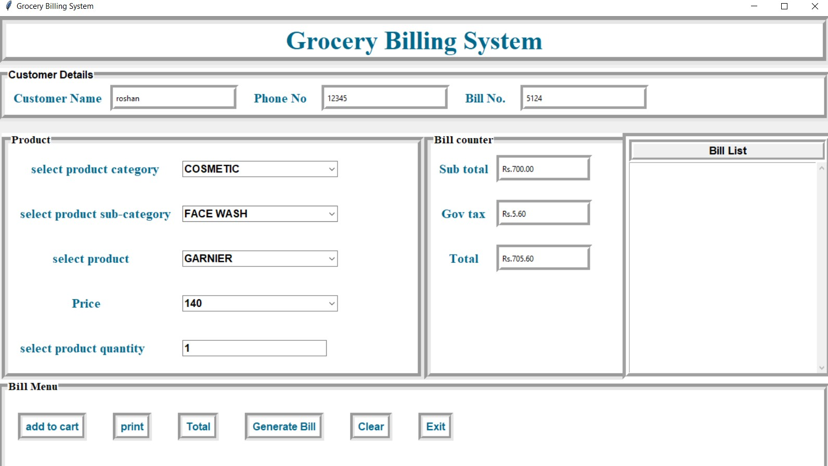

* **Bill counter**



* **Bill area**

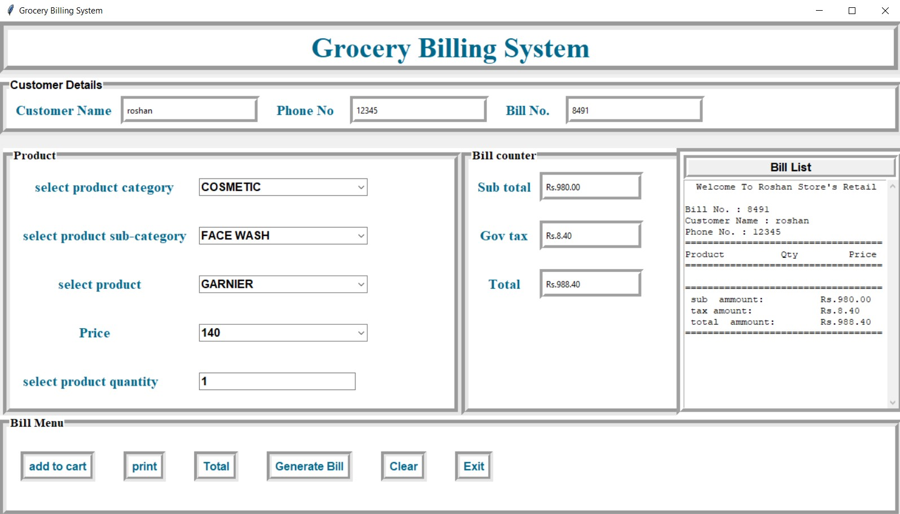

* **Bill menu**

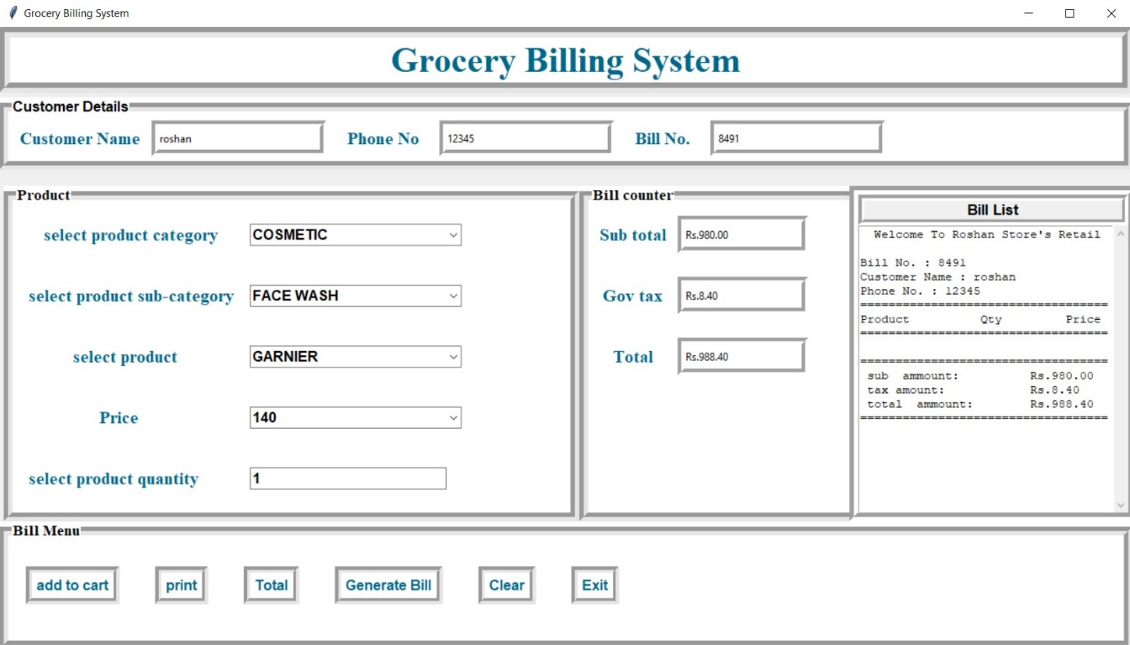

* **Whole billing system**

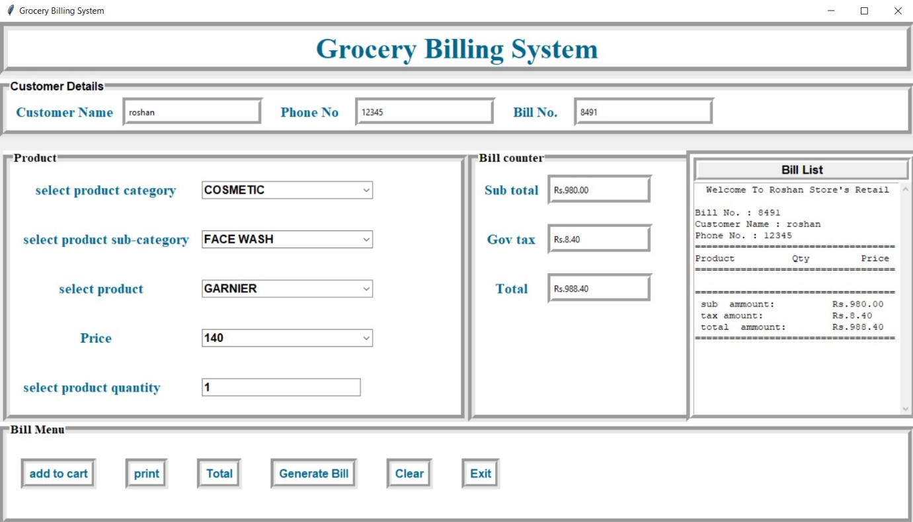

**CONCLUSION**

This was my project of System Design about "Billing System".

Development of this System takes a lot of efforts. I think this system gave a lot of satisfaction. Though every task is never said to be perfect in this development field even more improvement may be possible in this system. I learnt so many things and gained a lot of knowledge about development field. I hope this will prove fruitful.

**THANK YOU**

**😊**